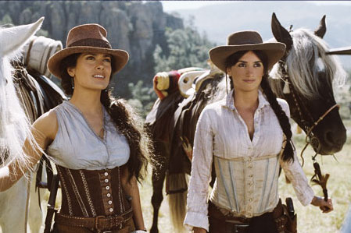


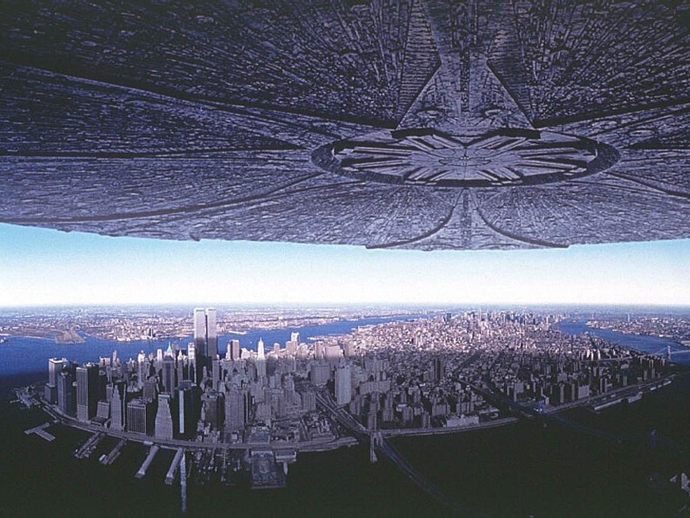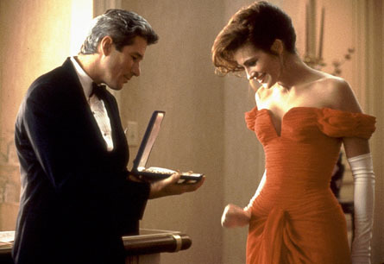

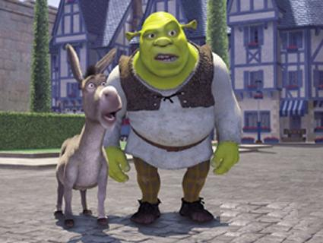
Genres: Films (UK) / Movies (USA)
 | Title | Genre | Stars
1 | 300 (2006) | War | Gerard Butler
2 | Bandidas (2006) | Western | Salma Hayek, Penelope Cruz
3 | Date Night (2010) | Comedy | Steve Carell, Tina Fey
4 | The Fast and the Furious (2001) | Action | Paul Walker, Vin Diesel
5 | Independence Day (1996) | Sci-Fi | Will Smith
6 | Pretty Woman (1990) | Romance | Richard Gere, Julia Roberts
7 | Shrek (2001) | Animation | Mike Myers (voice of Shrek)
8 | It (2017) | Horror | Jaeden Lieberher, Bill Skarsgård

Questions: Film / Movie Genres: TV / Series Genres:
- Have you seen this film? Comedy Satire Soap opera Comedy
- Did you like it? Epic Crime Kids Cooking / Culinary
- What is the name of this film? Western / Wild West War News Medical
- What kind of film is it? Adventure Suspense Sports Music
- Who stars in this film? Historical Political Educational Travel
Action Drama Sci-Fi Documentary / Historical
UK USA Sci-Fi Fantasy Variety show Action
cinema movie theater Romance Musical Chat show Detective / Cop
movies Animation Cartoon Home + Health
Horror Kids Sitcom (situation comedy)
Romantic Comedy Anime

